**Ecological Pyramids Worksheet**

**Ecological Pyramids**

* Ecological Pyramids can be used to show the transfer of ____________ between trophic levels in a food chain.
* They can also show the ___________ of individual organisms at each trophic level.

Draw ecological pyramids for the food chains below.

Grass 🡪 Rabbit 🡪 Snake 🡪 Hawk

Seaweed 🡪 Tadpoles 🡪 Small fish 🡪 Large fish 🡪 Pelican

**Pyramid of Energy**

* This type of ecological pyramid shows how much _________ is available at each trophic level.
* The level with the most available energy is the _______________________ and the level with the least available energy is the _____________________.
* Only ____% of energy contained in each level is passed onto the next.
* 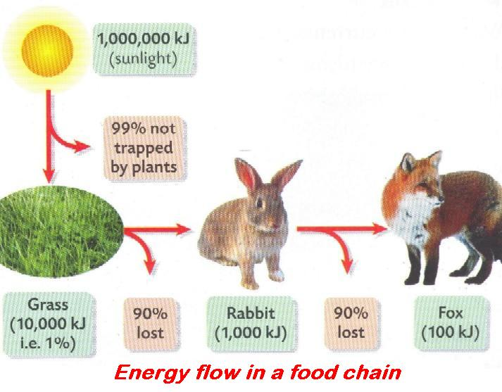The rest of the energy ___________________________________________.

Use the diagram below to draw a pyramid of energy.

**Upright Pyramid of Numbers**

* This type of pyramid shows _____________ organisms are at each trophic level.
* Most of the organisms are at the ­­­_________ of the pyramid.
* As you move up the pyramid, the number of organisms _______________, while the size of the organisms ________________.

Label the pyramid below with the trophic levels and appropriate organisms.

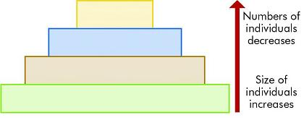

**Inverted Pyramid of Numbers**

* This type of pyramid also shows _____________ organisms are at each trophic level.
* In an inverted pyramid, there is ­­­­________________ producer organism at the first trophic level.
* One tree can feed __________________.

Label the pyramid below with the trophic levels and appropriate organisms.

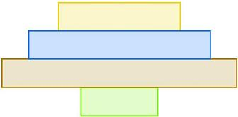

Place the following numbers and words in each of the pyramids. Label each pyramid as an energy pyramid or a pyramid of numbers.

50, 000 kJ 45 hawks 5, 000 kJ 50 kJ

456, 000 mice 4, 500 snakes 500 kJ 4, 560, 100 corn stalks